Year 6 maths quiz: memory mastermind!
Multiplication and division vocabulary
- List all the factors of 18: _______________________________________
- List all the common factors of 24 and 12: _______________________________________
- List all the prime numbers under 30: _______________________________________
- List the first 6 multiples of 9: ____, ____, ____, ____, ____ and ____
- What is the lowest common multiple of 4 and 6? _____
- First 12 square numbers
Angles
Complete the grid.
How many degrees…
in a full turn? | °
in a half turn? | °
in a right angle? | °
in an acute angle? | °
in an obtuse angle? | °
on a straight line? | °
inside a triangle? | °
inside a quadrilateral? | °

Fractions, decimals & percentages
Complete the conversion grid.
Fraction | Decimal | Percentage
½
 | 0.2
 |  | 1%
 | 0.125
¾
 | 0.25
 |  | 5%

Shape vocabulary
Draw a horizontal line. | Draw a vertical line. | Draw a pair of parallel lines. | Draw a pair of perpendicular lines. | Label this circle with its circumference, radius and diameter.

1 = | I | = | X | 100 = |  | 1000 =
= | V | 50 = |  | = | D
Roman numerals
Complete the grid.

2D shapes
What is a polygon? _______________________________
What’s the difference between a regular an irregular polygon? ________________________________________________________
________________________________________________________
What is the area of this triangle?
Area = ___________

What is the area of this parallelogram?
Area = ___________

Complete the grid.
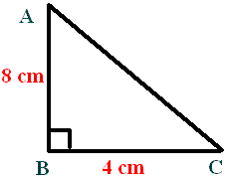
Name | No. of sides
octagon
 | 5
nonagon
 | 7
quadrilateral
 | 10
hexagon

Below each shape, write its name (don’t just write ‘triangle’ for the first 3 – be specific!)
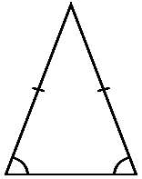 | 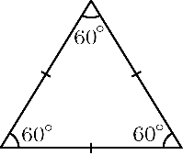 | 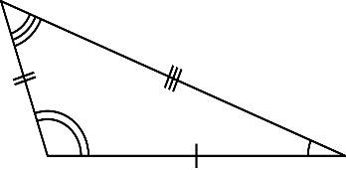 |  |  | 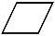

Measurement conversions
- List all the months that have exactly 31 days: ___________________________________________________
- List all the months that have exactly 30 days: ___________________________________________________
- What’s different about a leap year? ___________________________________________________________
Complete the conversions.
1cm = mm | 1km = m | 1 litre = ml
1m = cm | 1 mile = km | 1 kilogram = g

The mean
What is the mean of the following numbers?
5, 7, 2, 8, 3
Mean = ____________

,5).

3D shapes (Thurs)
Complete the grid. | 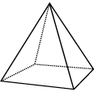 | 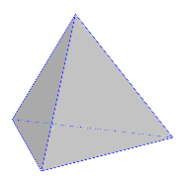 | 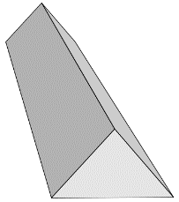
What is this shape called?
How many faces does it have?
How many edges does it have?
How many vertices does it have?

What’s the volume of this cuboid? _______________
